Title: the combo impact of silica fume and glass fiber on the rheology properties of 3D-printing cement

## Abstract:

## Keywords:

## 1. Introduction:

The water reducer can modify the viscosity of the cement paste.

The glass fiber can increase the tensity and yield stress of the cement paste.

Main purpose: To control and maintain the mixture characteristics suitable for printing.

## 2. Methods:

### 2.1 Material

Pure Grade Portland Cement type PI 42.5 was used to eliminate the effect of admixtures and w/c on the tests. The physical and chemical properties are shown in Table 1.

Table 1. The properties of the Portland cement

|  |  |  |  |
| --- | --- | --- | --- |
|  |  |  | content |
| Water requirement of normal consistency |  | C3S |  |
| Initial setting time |  | C2S |  |
| Final setting time |  | C3A |  |
|  |  | C4AF |  |

The corn oil was used here to adjust the apparent viscosity of the cement paste. It will also have a sub-effect on the static yield stress of the cement paste which is also a significant property in 3D-printing. This is because the apparent viscosity and static yield stress are all rheologic parameters of cement paste which is related to the inside micro-structure. The glass fiber was utilized to change the static yield stress of the cement paste, in order to enhance the buildability of cement 3D-printing. When the cementitious material was extruded, the static yield stress decides whether your printed structure can stand or destroy.

### 2.2 Orthogonal test

In order to figure out the impact of water cement ratio (w/c), the content of corn oil and the content of glass fiber on mixture’s viscosity and static yield stress, orthogonal test was considered to investigate the influence. It is because the orthogonal test is a suitable method to study many factors and levels which have an even distribution as it reduces the experiment time dramatically(Wang, Lin, Liu, Xu, & Feng, 2019; Zhou, Shi, & Wu, 2013).

As shown in Table 1, w/c (Factor A), Corn oil content (Factor B) and glass fiber content (Factor C) were selected as the three factors which are thought to have impacts on the viscosity and yield stress. The levels of w/c were 0.35, 0.4 and 0.45, respectively. The corn oil content were 0, 0.5% and 1%. The glass fiber content had 0, 0.5% and 1% three levels.

Table 1. Orthogonal experimental factors

|  |  |  |  |  |
| --- | --- | --- | --- | --- |
| Factors | | A: w/c | B: Corn oil content/% | C: Glass fiber content/% |
| Levels | 1 | 0.35 | 0 | 0 |
| 2 | 0.40 | 0.5 | 0.5 |
| 3 | 0.45 | 1 | 1 |

The orthogonal test in this study were designed with the help of 3 factors and 3 levels orthogonal table as shown in Table 2.

Table 2. Orthogonal experimental scheme

|  |  |  |  |
| --- | --- | --- | --- |
| No. | w/c | Corn oil/% | Glass fiber/% |
| 1 | 0.35 | 0 | 0 |
| 2 | 0.40 | 0.5 | 0 |
| 3 | 0.45 | 1 | 0 |
| 4 | 0.45 | 0.5 | 0.5 |
| 5 | 0.40 | 0 | 0.5 |
| 6 | 0.35 | 1 | 0.5 |
| 7 | 0.35 | 0.5 | 1 |
| 8 | 0.40 | 1 | 1 |
| 9 | 0.45 | 0 | 1 |

### 2.3 Testing process

The testing material should be prepared before testing. An automatic agitator is used in material preparing. The mass of the cement and water used in each test has shown in Table 2. In order to meet the requirement of the viscometer, total 1000 g cement paste was prepared. The mass of the cement and water needed in different w/c are shown in Table 2.

Table 2 The mass of cement and water in different water cement ratio.

|  |  |  |  |
| --- | --- | --- | --- |
| w/c | Total mass(g) | Water(g) | Cement(g) |
| 0.35 | 1000 | 260 | 740 |
| 0.40 | 1000 | 286 | 714 |
| 0.45 | 1000 | 310 | 690 |

The procedure to prepare the cement paste is shown below. First, the weighted cement and glass fiber were poured into an iron bucket. Then the automatic agitator was used to stir the dry materials at the speed of 60 rpm for 2 min. Next, water was added, and the mixture was stirred with the agitator at 60 and 120 rpm for 1.5 and 2.5 min, respectively. After the rapid mixing had been completed, the corn oil was added into fresh mortar at the calculated volume. Finally, the mixture was stirred at 60 rpm for 2 min until the corn oil was fully integrated into fresh mortar. After mixing, the cement paste was poured into the beaker, and the rheology testing process was carried out according to the preset program.

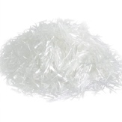

The Antonpar viscometer was used to test the yield stress and apparent viscosity of the designed cement paste.

The yield stress was measured by controlling the speed of the spindle at 0.1 round per minute (RPM). Figure 1 shows the shear stress changes with the time. As we can see, because of the thixotropy, the shear stress is not stable under the same shear speed. The shear stress of the cement paste reaches a top around 50 s, which represents the static yield stress of the tested material.

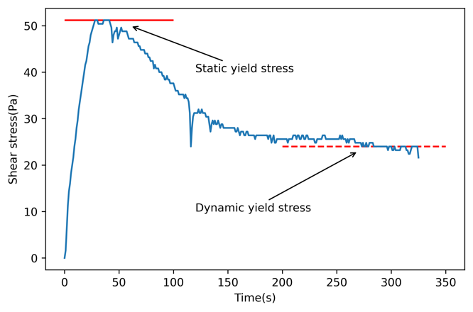

Figure 1. The static yield stress is chosen as the evaluation metric for the buildability of the printing cement.

When continuing the shearing, the shear stress started to decrease reaching an approximately stable level which represents the dynamic yield stress of the cementitious liquid. This is because the micro-structure break-up takes the dominant part in the tested cement paste.

### 2.4 variance analysis

Variance analysis is a statistical method to clarify the significance of different factors according to the results from orthogonal tests. The variance analysis can be described by the following formula.

$${SS}_{T}={SS}_{f}+{SS}_{e}$$

Where:

${SS}_{T}$ is the sum of squares for total;

${SS}_{f}$ is the sum of squares for regression;

${SS}_{e}$ is the sum of squares for error;

$${df}_{T}={df}_{f}+{df}_{e}$$

Where:

${df}_{T}$ is the total degree of freedom (DF);

${df}_{f}$ is the DF of one factor;

${df}_{e}$ is the DF of error;

The mean square of each factor, error and the F-value of each factor could be obtained using formula.

$${MS}_{f}=\frac{{SS}_{f}}{{df}_{f}}$$

$${MS}_{e}=\frac{{SS}_{e}}{{df}_{e}}$$

$$F_{f}=\frac{{MS}_{f}}{{MS}_{e}}$$

The critical value of $F_{c}$ has a significance level (α=0.1). If $F>F_{c}$, this factor can be considered a significant factor on experiment results.

## 3. Results:

|  |  |  |  |  |  |
| --- | --- | --- | --- | --- | --- |
| Test No. | w/c | corn oil | fiber | Viscosity (Pa*s) | Yield stress (Pa) |
| 1 | 1 | 1 | 1 | 18.19 | 130.4 |
| 2 | 2 | 2 | 1 | 8.346 | 51.2 |
| 3 | 3 | 3 | 1 | 6.848 | 37.6 |
| 4 | 3 | 2 | 2 | 7.062 | 57.6 |
| 5 | 2 | 1 | 2 | 11.340 | 132.8 |
| 6 | 1 | 3 | 2 | 15.190 | 313.6 |
| 7 | 1 | 2 | 3 | 16.260 | 179.2 |
| 8 | 2 | 3 | 3 | 9.630 | 146.4 |
| 9 | 3 | 1 | 3 | 8.346 | 89.6 |

### 3.1 viscosity

The test results of the viscosity on the 9 experiments are shown in Figure 1. As we can see, the group 1 get the highest viscosity, 18.19 Pa.s, while the group 3 gets the lowest value of 6.848.

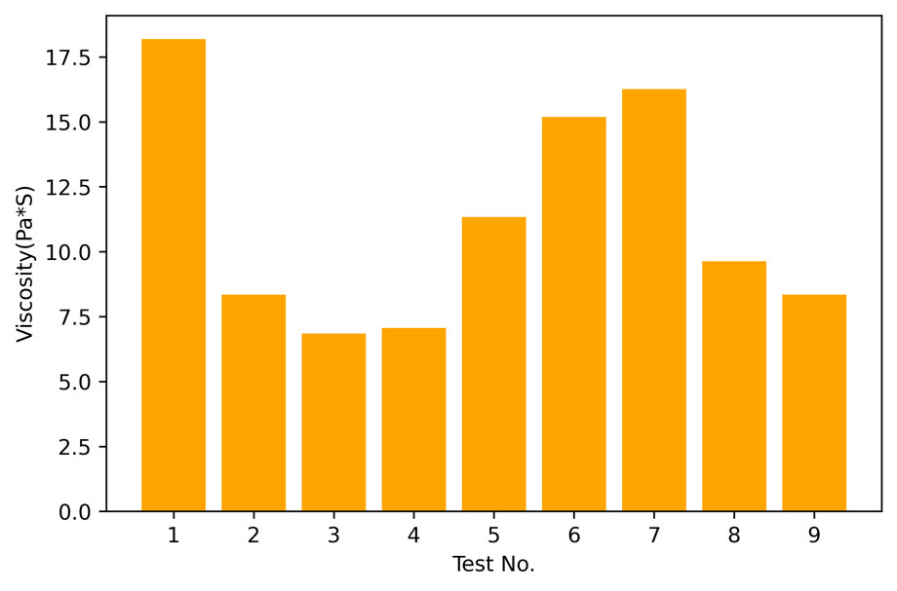

Figure 1. The viscosity values of each test.

The variance analysis was applied to the viscosity testing. The analyzing outcome is shown in Table 3.

Table 3. Variance analysis calculation results viscosity

|  |  |  |  |  |
| --- | --- | --- | --- | --- |
| Factor | SS | df | F (=0.1) | significance |
| A: w/c | 53.574 | 2 | 1.128 | 0.47 |
| B: corn oil | 32.939 | 2 | 0.693 | 0.591 |
| C: fiber | 129.136 | 2 | 2.719 | 0.269 |
| Error | 47.501 | 2 | / | / |

Table 3 shows that F values of factor C exceed the $F_{c}$ as the significance of factor C is 0.048<0.05. It indicates that the depth is significant on the detection error. The F value of factor C has the largest value, which means the depth has the greatest impact on the RMSE, followed by Area, Thickness. It should be noted that is similar to , indicating that the change of thickness has similar impact on the RMSE with the random error. In other words, thickness has almost no effect on the RMSE.

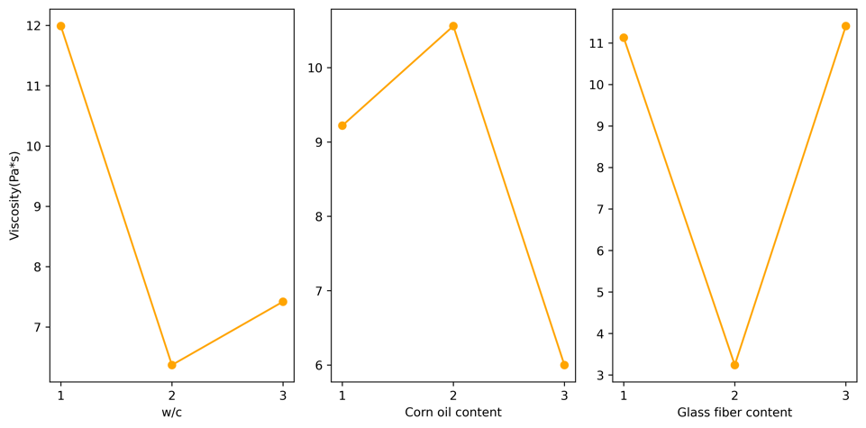

Figure 2. it is the estimated margin effect of the three factors on the viscosity. As we can see, if we want to lower the viscosity, the best combination is w/c = 0.40, corn oil = 1%, glass fiber content = 0.5%.

### 3.2 yield stress

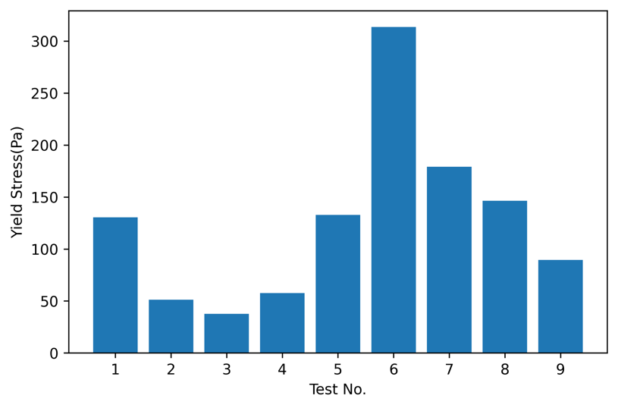

Table 4. Variance analysis calculation results_yield stress

|  |  |  |  |  |
| --- | --- | --- | --- | --- |
| Factor | SS | df | F (=0.1) | significance |
| A: w/c | 33236.196 | 2 | 11.678 | 0.079 |
| B: corn oil | 7677.582 | 2 | 2.698 | 0.27 |
| C: fiber | 14156.942 | 2 | 4.974 | 0.167 |
| Error | 2846.009 | 2 | / | / |

Table 3 shows that F values of factor C exceed the $F_{c}$ as the significance of factor C is 0.048<0.05. It indicates that the depth is significant on the detection error. The F value of factor C has the largest value, which means the depth has the greatest impact on the RMSE, followed by Area, Thickness. It should be noted that is similar to , indicating that the change of thickness has similar impact on the RMSE with the random error. In other words, thickness has almost no effect on the RMSE.

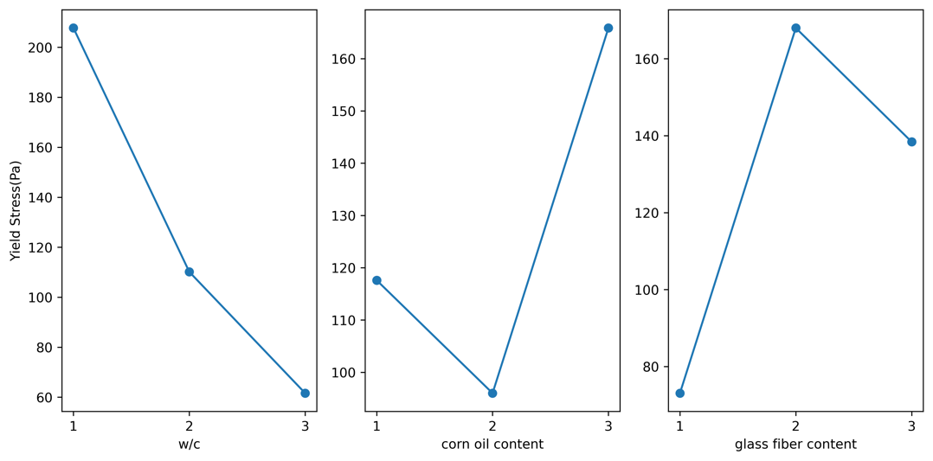

Figure 2. it is the estimated margin effect of the three factors on the static yield stress. As we can see, if we want a higher static yield stress, the best combination is w/c = 0.35, corn oil = 1%, glass fiber content = 0.5%.

Combining the results from yield stress and viscosity,

## 4. conclusion